Requirement Analysis
Data Flow Diagram & User Stories
Date | 8 October 2026
Student Name | OviyaShree
Project Name | Metro Ticket Generating System in ServiceNow
Maximum Marks

Logical Data Flow
Step | Flow
1 | Passenger opens the ticket booking Service Catalog item.
2 | Selects Source, Destination, Passenger Type and Number of Tickets.
3 | Catalog client scripts and UI policies auto-populate defaults (single / return journey).
4 | Client-side and server-side validation checks mandatory fields, station values and travel date.
5 | Fare Logic Script calculates the fare and confirms the fare match.
6 | QR code is generated and the digital ticket record is created.
7 | Flow Designer sends a Notification with the digital ticket.
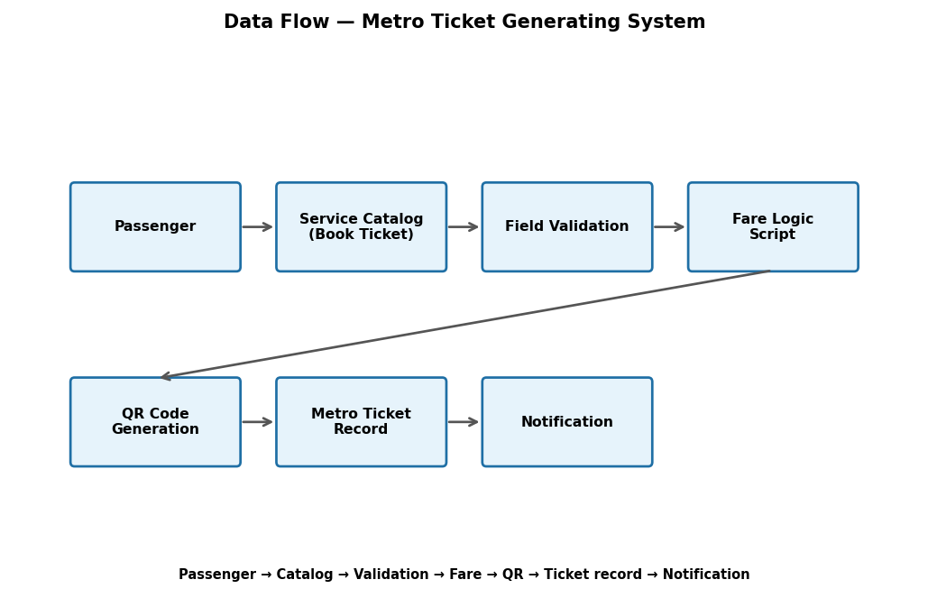
Figure 1: High-level Metro Ticket data flow.
User Stories
User Type | User Story | Acceptance Criteria | Priority
Passenger | Book a ticket by selecting source and destination. | Catalog form opens with all variables. | High
Passenger | See the fare calculated automatically. | Fare matches station and passenger type. | High
Passenger | Receive a digital ticket with a QR code. | QR code generated instantly. | High
Passenger | Choose single or return journey by default. | Default value auto-populated. | Medium
Station Manager | View ticket and station details. | Station details mapped to ticket. | Medium
Metro Operations Team | Monitor ticket bookings. | Booking records available. | Medium
IT Admin | Maintain catalog, scripts and flows. | Configuration editable. | Medium

